Running head: Using Technology to Enhance the Instruction of Positional Notation

Using Tablet PC and Smart Board Technology to Enhance the Instruction of Positional Notation for Second Grade Mathematics in South Dakota Classrooms

Dustin Mees and Josh Bergquist

LT 716
Elizabeth Simmons
University of South Dakota

Table of contents
Using Tablet PC and Smart Board Technology to Enhance the Instruction of Positional Notation for Second Grade Mathematics in South Dakota Classrooms 1
Table of contents 2
Using Tablet PC and Smart Board Technology to Enhance the Instruction of Positional Notation in Second Grade Mathematics in South Dakota Classrooms 4
Context analysis 4
Instructional Need 4
Learning environment 5
Learner analysis 6
Cognitive analysis 6
Physiological characteristics 7
Affective characteristics 8
Social characteristics 8
Design implications 8
Task analysis 9
Learning goal 9
Type of learning outcome 9
Information-processing analysis 9
Prerequisite analysis 9
Learning Objectives 10
Assessing learning from instruction 14
Purpose of your assessment instrument and the type of model 14
Necessary assessments 14
Item specification for each objective 14
Complete instruments (describe here but use appendices) 19
Strategies for instruction 22
Instructional management issues 32
Formative, summative and return on investment evaluations 38
Appendix A: Complete Test Form 39
References 43
Tables 44
Figures 45

Using Tablet PC and Smart Board Technology to Enhance the Instruction of Positional Notation in Second Grade Mathematics in South Dakota Classrooms

Often time’s students will enter into third-grade and will not have all of the prior knowledge that is required as a foundation on which to build upon. The focus for this instructional design is to build a stronger foundation of positional notation in our base-ten numbering system in such a way that students will leave second-grade with a higher retention level of the material. In order to increase the effectiveness of this instruction, students will be instructed using technology such as Tablet PCs and Smart Board software.

Context analysis

Instructional Need
A need for the instruction for this content is identified by standards set by the South Dakota Department of Education. Our goals for this instruction will be based of the South Dakota Department of Education Standards and Indicators (SDDOE, 2008, Content Standards section). The standards were developed by the South Dakota Board of Education, veteran educators, state agency staff, senior scholars, and interested citizens (SDDOE, 2008, Content Standards Overview section, para. 2). The South Dakota math standards were last revised and approved in the summer of 2004 (SDDOE, 2008, Content Standards: Math section). South Dakota indicators and standards are available to educators and the general public at the South Dakota Department of Education website. Because the standards were revised in 2004, it would be important to reassemble to panel to assess and evaluate the indicators and standards that will be addressed during this academic year. The panel will also consider aligning South Dakota math standards with standards created by the National Council of Teachers of Mathematics (NCTM). During deliberation, the panel will compare the indicators and standards in order to make sure that they align with the important knowledge aligned by the Dakota Step Test (SDDOE, 2008, Administration: Dakota Step section). There are three level of attainment for these goals: basic, proficient, and advanced. In order to achieve our instructional goals, it is desired that all students will perform at a proficient to advanced level.

Learning environment

Teachers for the course: range of experience, interests, backgrounds, preferences. Instructors of this content will range from first-year teachers fresh out of college to veteran teachers with over 30 years of experience. The minimal requirement will be a baccalaureate degree in Elementary Education. Other teachers may have further education ranging from a masters to a doctorate degree. Teachers will vary in their technology backgrounds. Newer teachers that recently had courses in technology instruction may have a better understanding of how to use technology in their classrooms. More veteran teachers, who have not had any further instruction on how to effectively use technology in their classrooms, may require further education and training on using technology effectively in their classrooms. All teachers will vary in their instructional preferences.
- Existing curricula (scope and sequence) into which this course fits. This instructional unit will fit within the already described criteria listed for any South Dakota second-grade classroom. Every student will need this foundational understanding of positional notation in order to move further into their exploration of mathematics.
- Instructional hardware that is currently available. Second-grade classrooms have the following technology: television, VCR/DVD, one Apple desktop, two Gateway desktops, one-to-one ratio between students and Tablet PCs, and a projector that is connected to the teacher’s computer and the Smart Board. The technology that will primarily be used for this instruction will be the Tablet PCs and the Smart Board.
- Classes and facilities that will use the course. All second-grade classrooms will vary in size between 9 and 32 students with the typical class averaging 18 to 27 students. A typical second grade classroom has movable desks, chairs, tables, various writing supplies, and media.
- School or organization in which the learning will take place. The content will be instructed in second grade classrooms across South Dakota. There will be varying in-service conducted among South Dakota school districts where teachers will learn how to use this technology effectively in their classrooms.
- Community in which the school or organization resides. The communities that this instructional design will be used in will be located in the state of South Dakota. The majority of these communities is rural and has a small population.

Learner analysis

Cognitive analysis
a. General Characteristics
In general, members of this class are seven years going to be turning eight years old in the second grade classroom. By the time they reach this level in their education, they will generally be able to read and understand simple instruction. Most students will benefit from visual and hands-on learning. These students will benefit most by being able to visualize the connections being made to the content. Students enter second grade and a preoperational level where they learn to reason and problem solve (Smith & Ragan, 2005, p. 67). As the school year progresses, students move towards a concrete operation level. At this intellectual stage, students develop classification, ordering, and reversal of operation skills (Smith & Ragan, 2005, p. 67).
b. Prior Knowledge.
Students’ prior knowledge of content will vary. According to the South Dakota Department of Education Standards, students should enter second grade with the following knowledge in regards to positional notation. First, students should know how to count, write, and read numbers from 0 to 50 (SDDOE, 2008, Content Standards: Second-Grade Math section). Second, students should be bale to add and subtract with numbers from 0 to 20 written horizontally and vertically (SDDOE, 2008, Content Standards: Second-Grade Math section). Last, students should be able to solve problems dealing with addition and subtraction with numbers 0 to 20 in context (SDDOE, 2008, Content Standards: Second-Grade Math section).

Physiological characteristics
Students in the second grade classrooms will range in age from seven- to eight-years-old. The classrooms will include an even representation of boys to girls. The only physiological characteristic that will have an impact on the student’s ability to learn positional notation using this instructional design is a disability in the area of fine motor skills. Adaptations and modifications will be applied whenever necessary. Some examples may include wrapping tape or material around the stylist to make it easier to grip for students with a disability in the area of fine motor skills, changing the brightness or pixel settings on the screen for those who may have a visual disability, or allowing students with hearing disabilities to use headphones in order to better hear the sound effects and instruction from the computer.

Affective characteristics
Young children in this age range are excited to learn using hands-on activities and technology. They are motivated and interested in learning about the world around them. In general, today’s students have a low anxiety when using technology because they are growing up with it. Often, students have a higher anxiety when learning mathematics. This instructional design integrates technology as one of the primary instructional tools so that students will become more engaged and comfortable with the content.

Social characteristics
Generally, students at this age level are eager to work in groups and cooperate with each other. Students are usually at the preconventional morality stage of Kohlberg’s Moral Stages of Development. According to Kohlberg, children at this stage behave in fear of being punished and are motivated to follow rules if they feel they will be compensated for it (Smith & Ragan, 2005, p. 68). Socio-economic, racial, and ethnic backgrounds will vary in second grade classes. Socio-economics may have an impact with this instruction with students who come from a low-income family and may not be exposed to technology at home.

Design implications
a. If students have not previously been exposed to Tablet PCs, there will be a short orientation to introduce this technology to the students.
b. Students will go through instruction on the Tablet PCs at their own pace.
c. Instruction on the Tablet PCs will expose students to many different applications and activities involving positional notation.
d. Students will be given immediate feedback when answering a question on Tablet PC. If the answer is incorrect, the student will be given corrective feedback.
e. The teacher will give whole class instruction using the Smart Board to help solve common problems and answer questions involving positional notation.
f. The teacher will give informal assessment to make sure students understand content.
g. There will be a summative assessment that will measure student’s knowledge and understanding of positional notation given on the Tablet PC at the end of the unit.

Task analysis
In this task analysis the learning goal and the type of learning outcome that is desired from this instructional design are explained. Also discussed are the prerequisites for the unit and the learning objectives that outline the purpose of the instructional design.

Learning goal
Given multi-digit numbers, students will be able to perform varying mathematical tasks while observing the rules of positional notation.

Type of learning outcome
This is a procedural goal because it requires the students to determine if the procedure is applicable, recall the steps of the procedure, apply the steps in order, and confirm the end result is reasonable (Smith & Ragan, 2005, p. 87).

Information-processing analysis
The information-processing analysis would start with the student determining if the problem is an addition or subtraction problem. The analysis ends with the student calculating the exact result (see Figures 1 and 2).

Prerequisite analysis
The main prerequisite knowledge for students coming into this unit is that they already know how to add and subtract single digit numbers. For this instructional design prerequisite purpose we decided to focus on the prerequisites for solving story/word problems that deal with addition and subtraction. Our first learning objective asks students to be able to solve various forms of word problems. There are several prerequisite steps that students must know in order to properly solve these types of problems (see Figure 3).

Learning Objectives
Below are the terminal objectives for addition and subtraction in relation to positional notation for second graders. These objectives will measure students’ comprehension and ability to solve addition and subtraction equations in various forms such as time, currency, different bases and story/word problems.
Objective 1. Given various word problems using addition or subtraction, students will be able to reach the exact result, which should be written in correct positional notation, with 72% accuracy.
Is this a subtraction problem?
Yes
No
Select Another Approach
Recall the steps in subtracting 2 digit numbers
Is this a word story problem?
No
Yest
Begin regular subtraction procedure.
Select appropriate information and write into vertical equation
Subtract numbers on right column (ones place)
If bottom number is larger than the top number, you need to borrow from tens column. One ten equals ten ones. Write difference below
Subtract the 2 numbers from the tens column and write below the difference.
Make sure the numbers in the difference are written in the proper positional notation
If answer does not make sense go through procedures again to find mistake
Figure 1
Is this an addition problem?
Yes
No
Select Another Approach
Recall the steps in adding 2 digit numbers
Is this a word story problem?
No
Yest
Begin regular addition procedure
Select appropriate information and write into vertical equation
Add 2 numbers on right column (ones place)
If sum of these 2 numbers is larger than 9, carry the tens over into the tens column (left column)
Add 2 digits plus any number that was carried over from ones column in the tens column.
Make sure the numbers in the sum are written in the proper positional notation
If answer does not make sense go through procedures again to find mistake
Figure 2
Selecting appropriate information in a word story problem
Recognizing key words
Left or Left over
How many more
Difference
Total
Sum
All Together
Represents Subtraction
Represents Addition
Select the correct numbers and use these representations to correctly set up the equation.
Figure 3
Objective 2. Given addition and subtraction problems using two-digit numbers, written both horizontally and vertically, students will be able to demonstrate the correct mathematical procedures to reach the correct result with 86% accuracy.
Objective 3. Given various scenarios with time or currency, students will be able to follow the correct procedures for positional notation to reach desired result with 72% accuracy.

Assessing learning from instruction

Purpose of your assessment instrument and the type of model
The purpose of the assessment is to provide immediate feedback, evaluate students’ level of understanding, identify weaknesses and strengths of instruction, and highlight concepts that need further review. Students will not be compared or ranked. This model of assessment is the criterion-referenced model.

Necessary assessments
A pre-assessment will be administered using the Tablet PC software program before instruction. Informative whole-class quizzes will be administered by the teacher during instruction. Daily modules on the Tablet PC will be automatically graded by the software and provide immediate feedback for the user. There will be a post-test provided by the Tablet PC software after instruction.

Item specification for each objective

Terminal Objective 1: Given various word problems using addition or subtraction, students will be able to reach the exact result, which should be written in correct positional notation, with 72% accuracy

Description of Test Form: The test form that the students will take will be a short constructed answer item in the form of digits.

Sample Item:
Directions: Carefully read the word problem and select the important information to construct your addition or subtraction problem. Please label your answers.
Janet made 12 cookies in the morning. Arthur came over in the afternoon and ate five cookies. At the end of the day, how many cookies are left in the cookie jar?
Question Characteristics:
- For this question, the story problem is requiring students to create a subtraction problem.
- The story problem will have only two numbers in it.
- One of the numbers must be a two-digit number ranging from 10 to 20.
- The other number could be a one-digit or two-digit number ranging from 1 to 20.
- The story problem is requiring the students to label the answer “cookies.”
Response Characteristics:
- For this problem, the only correct answer is seven cookies.
- Possible incorrect answers include: 17 cookies, 7 without the label, and 13 due to not observing the rules of positional notation.
- During the student’s response, he or she may write the subtraction problem out horizontally or vertically.
Number of Items and Mastery Criterion: The minimum number of items is seven with a mastery of 5/7.

Terminal Objective 2: Given addition and subtraction problems using two-digit numbers, written both horizontally and vertically, students will be able to demonstrate the correct mathematical procedures to reach the correct result with 86% accuracy.
Description of Test Form: Short Constructed Answer Item
Sample Item:
Directions: Answer the following addition and subtraction problems following the rules of positional notation. Show all work.
18 + 9 = ___________ 15 – 8 = _________
Question Characteristics:
- Each problem will consist of two numbers.
- Each problem will be an addition or subtraction problem.
- One number must be a two-digit number.
- The other number can be a one-digit or a two-digit number.
- Each question can be horizontally or vertically written.
Response Characteristics:
- If the problem is addition, the student may accidentally subtract.
- If the problem is subtraction, the student may accidentally add.
- Students will type their answer in the blank.
- Student may retype problem vertically if the problem is originally shown horizontally.
Number of Items and Mastery Criterion: The minimum number of items is seven with a mastery of 6/7.

Terminal Objective 3: Given various scenarios with time or currency, students will be able to follow the correct procedures for positional notation to reach desired result with 72% accuracy.
Description of Test Form: Multiple Choices
Sample Item:
Directions: Solve the addition or subtraction problem by observing the rules of positional notation. Make sure you notice what variable you are working with. Label your answer accordingly.
Jan went to the store with $20 in her pocket. She bought a shirt for $12.50. How much money is left in Jan’s pocket after her purchase?
  - $8
  - $7
  - $7.50
  - $32.50
Question Characteristics:
- The questions will ask the students to work with time or currency.
- If the question deals with currency, the problem will consist of two numbers, one must be two-digit ranging 10 to 20 while the other can be one or two-digits.
- If the question deals with time, the problem will consist of two times. Students can be asked to find elapsed time or travel time between two different time zones.
Response Characteristics:
- There will be four answers to choose from, one correct and three distracters.
- Each distracter will be in the correct variable format used in the problem. An example would be all answers dealing with time in a time problem.
Number of Items and Mastery Criterion: the minimum number of items is seven with a mastery of 5/7.
Instrument blueprint
Objectives:
The three terminal objectives used in this instructional design will be represented in the instrument blue print. There will be seven items for each objective on the assessment.

Terminal Objectives:
Objective 1. Given various word problems using addition or subtraction, students will be able to reach the exact result, which should be written in correct positional notation, with 72% accuracy.
Objective 2. Given addition and subtraction problems using two-digit numbers, written both horizontally and vertically, students will be able to demonstrate the correct mathematical procedures to reach the correct result with 86% accuracy.
Objective 3. Given various scenarios with time or currency, students will be able to follow the correct procedures for positional notation to reach desired result with 72% accuracy.
Forms of Items: Multiple Choice and Constructed Response
Total Number of Items in Instrument: 21
Proportionality of Items: There are seven items for each objective
Directions for Administration: Students are not allowed to use notes or textbooks and should work individually.
Scoring Methods: In the classroom, this assessment, using the Tablet PC, will be automatically scored on each computer. However, for this instructional design, a key will be attached below the assessment.
Weighting of Items: Each item for each objective will be worth one point on the assessment.
Passing or Cut-Off Level: For terminal objective one, the passing level is five out of seven. For terminal objective two, the passing level is six out of seven. The passing level for terminal objective three is five out of seven. The overall passing level for the assessment is sixteen out of twenty-one.

Terminal Objectives | Form | Number of Items | Criterion Level | Proportion
Objective 1 | CR | 7 | 5/7 | .333
Objective 2 | CR | 7 | 6/7 | .333
Objective 3 | MC | 7 | 5/7 | .333
Table 1

Complete instruments (describe here but use appendices)
Positional Notation Test
Directions: Answer the following addition and subtraction problems following the rules of positional notation. Show all work.
- 13 + 7 = ________

- 11 + 19 = ________

- 16 – 9 = _________

- 20 -11 =_________

- 14 -8 =__________

- 17
+7

- 16
- 7

Part 2
Directions: Carefully read the word problem and select the important information to construct your addition or subtraction problem. Please label your answers.
- Janet made 12 cookies in the morning. Arthur came over in the afternoon and ate five cookies. At the end of the day, how many cookies are left in the cookie jar?

- Tom had 11 baseball cards. His dad bought him a pack that contained 9 cards. How many cards does Tom have altogether?

- Ray has 10 goldfish. Mary has 14 goldfish. How many more goldfish does Mary have then Ryan?

- Bill has a bag of 16 apples. Todd and Kayla had 7 more apples to his bag. How many apples are now in Bill’s bag?

- Anna invited 18 friends to her party. Only 9 friends showed up. How many of Anna’s friends did not come to her party?

- Joe has 8 pairs of shoes and Lana has 13 pairs of shoes. How many shoes do Joe and Lana have together?

- Nate’s dad drives 15 miles to work. Larry’s dad drives 8 miles to work. How many more miles does Nate’s dad drive then Larry’s dad?

Part 3
Directions: Solve the addition or subtraction problem by observing the rules of positional notation. Make sure you notice what variable you are working with. Label your answer accordingly.
- Jan went to the store with $20 in her pocket. She bought a shirt for $12.50. How much money is left in Jan’s pocket after her purchase?

- $8
- $7
- $7.50
- $32.50

- Ryan has practice at 3:00 PM. It is 2:15 PM that day. How much time does he have before practice starts?

- 45 minutes
- 1 hour and 45 minutes
- 30 minutes
- 1 hour and 15 minutes

- Corey had $17 saved. He washed Mrs. Smith’s car for $9.75. How much money does Corey have altogether?

- $27
- $26.75
- $8.75
- $26

- Kim decided to go for a job at 5:45PM. She ran for 17 minutes. What time was it when she got back from her job?

- 5:00 AM
- 5:62 PM
- 5:38 PM
- 6:02 PM

- Jared needs to be to school at 8:05 AM. It is 7:30 AM and he is just getting on his bike. How many minutes does Jared have to get to school?

- 1 hour and 30 minutes
- 30 minutes
- 35 minutes
- 25 minutes

- Kelly got $15 from her grandpa for her birthday. Her friend gave her $7. How much money did Kelly get for her birthday?

- $22
- $8
- $14
- $20

- Tom really wants a baseball cap that costs $20. He only has $11.50. How much more money does he need to buy the baseball cap?

- $9
- $8.50
- $31.50
- $8

Strategies for instruction
The strategy for instruction in this instructional design project will be based on procedural learning. In procedural learning, students will learn steps to follow when addressing problems dealing with positional notation.
Objectives:
Objective 1. Given various word problems using addition or subtraction, students will be able to reach the exact result, which should be written in correct positional notation, with 72% accuracy. The following are the procedural steps for solving addition and subtraction word problems dealing with positional notation.
- Find out if the word problem is an addition or subtraction problem. Look for key words in the problem to give a clue to the type of function desired.
- Select the important numbers from the problem.
- Construct the appropriate addition or subtraction problem vertically or horizontally.
- Follow the usual procedures for solving an addition or subtraction problem.
Synopsis of Context and Strategy:
The context outlined in this objective requires that students have prior knowledge in not only mathematics, but also in the meaning of certain words in the English language. In order to comprehend what the word problem is asking the students to do, they must know that words such as total, combined, and all together signify that the function is addition. In the opposite, words such as less, left, and more signify that the function is subtraction. Students should also have a basic prior knowledge dealing with addition and subtraction of single-digit numbers.
The knowledge that students must apply to this prior knowledge will be gained through teacher instruction and technology guided instruction with the use the Tablet PCs in the classroom. This additional knowledge will help the students perform varying tasks dealing with addiction and subtraction of one two-digit number by another number that can be one- or two-digits.
The strategy for instruction that will be used to administer this instructional design is instruction that leads to the learning of procedures. Exposing students to various problems dealing with the same underling context will allow them to use the same procedure over-and-over in order to solve different problems. This will reinforce the students’ ability to learn the proper procedure for adding and subtracting while observing the proper rules of positional notation. The instructional software that will be used on the Tablet PC will provide this instruction for the students to work individually with different styles problems dealing with currency, time, and our base-ten numbering system. The software will also provide the students with immediate feedback if the answer is either right or wrong. If the answer was incorrect, there will be an explanation provided by the software which acts as a reinforcing instruction tool. The classroom teacher will also act as an instructor, but he or she will be instructing the whole class using the Smart Board.
Introduction:
The introduction for this lesson will involve the teacher activating prior knowledge. He or she will show different addition and subtraction problems that are one-digit by one-digit. By calling on different members of the class this will give a review of how to add or subtract one-digit numbers. The teacher will then ask if the students know of any other ways to write an addition or subtraction problem.
Attention:
In order to gain further attention of the students, the teacher will ask for examples of word problems from the students. Maybe on student will say, “Over the weekend my mom baked 12 cookies. My brother and I ate 8 cookies together. How many cookies are left?” The students may need a little assistance in forming the problem, but now the teacher has an example problem that was supplied by the students. Making this connection will in turn make the information more real and personal for the students. The teacher may repeat this step until he or she feels that he or she has adequately accessed the students’ prior knowledge.
Purpose:
The purpose of teaching this content is that by learning this basic content of how to dissect the meaning of and then solve word problems, students will be able to solve problems presented in this format even when they are introduced to further context such as multiplication and division. The same procedure for addressing word problems is used no matter what the function being used. Just as the rules for positional notation are true no matter what classification or base you are working in.
Interest and Motivation:
The students will be interested and focused because of the anticipatory set described under the “attention” heading above. To further motivate the students, the teacher will pass out manipulatives, some of which may be edible. As a class, with the word problems displayed on the Smart Board, the teacher will go through different steps for using manipulatives to help solve problems. Once the students refresh this knowledge he or she will demonstrate the Tablet PC software that sues built-in manipulatives that the students may drag and place using the Stylist. While the students eat their edible manipulatives, they will watch and learn how to use this program to solve word problems dealing with positional notation on their own with the Tablet PC. Then the teacher will pass out a Tablet PC to each student, which will also act a major motivational tool.
Preview:
For this objective, there are two procedures that must be previewed for the students. The teacher will go over the procedural steps that are followed when addressing a word problem. The teacher will also go over the procedural steps for positional notation when adding or subtracting. The students will also be informed of how the rest of the lesson will carry out so that they are comfortable with the class and where it is heading. The students will be informed that they will review the different procedures being used during the lesson, followed by a demonstration, then practice with the primary instruction being provided by the Tablet PC, and finally an assessment that will inform the students and the teacher of how well they learned the procedures.
Body:
The body for this lesson will provide information on how to access prior knowledge, information and examples, the focus of attention, and how to employ the learning strategies.
Prior Knowledge:
In order to gain further attention of the students, the teacher will ask for examples of word problems from the students. Maybe on student will say, “Over the weekend my mom baked 12 cookies. My brother and I ate 8 cookies together. How many cookies are left?” The students may need a little assistance in forming the problem, but now the teacher has an example problem that was supplied by the students. Making this connection will in turn make the information more real and personal for the students. The teacher may repeat this step until he or she feels that he or she has adequately accessed the students’ prior knowledge.
Information and Examples:
The information covered in this lesson for objective one will deal with addressing word problems and performing the tasks assigned while observing the proper rules and procedures for positional notation. The word problems may deal with currency, time, and/or our base-ten numbering system. These problems will be administered to the students along with further instruction by the use of Tablet PCs. Below are examples of two different screen shots in order to better understand what the students will be working with.
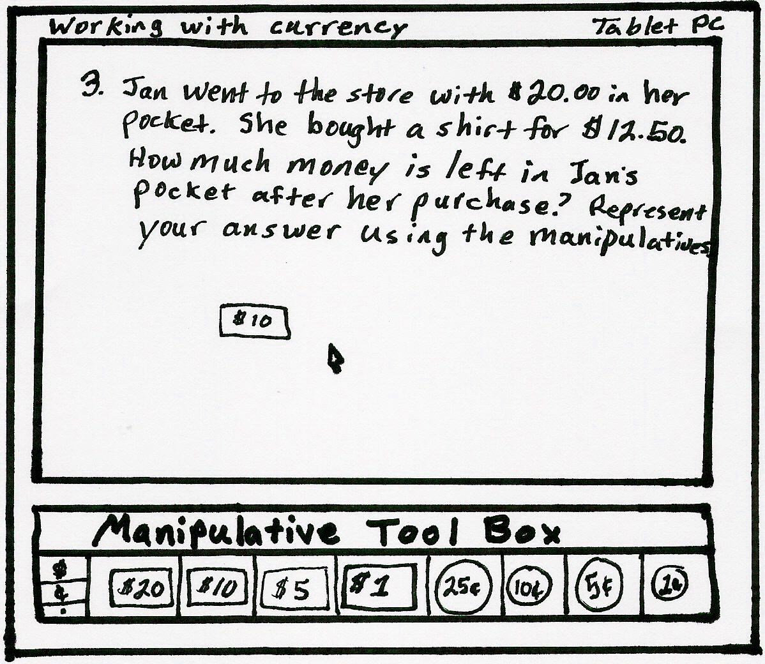
Figure 4: Screen shot of a student working on the Tablet PC with currency. Image created by
author.
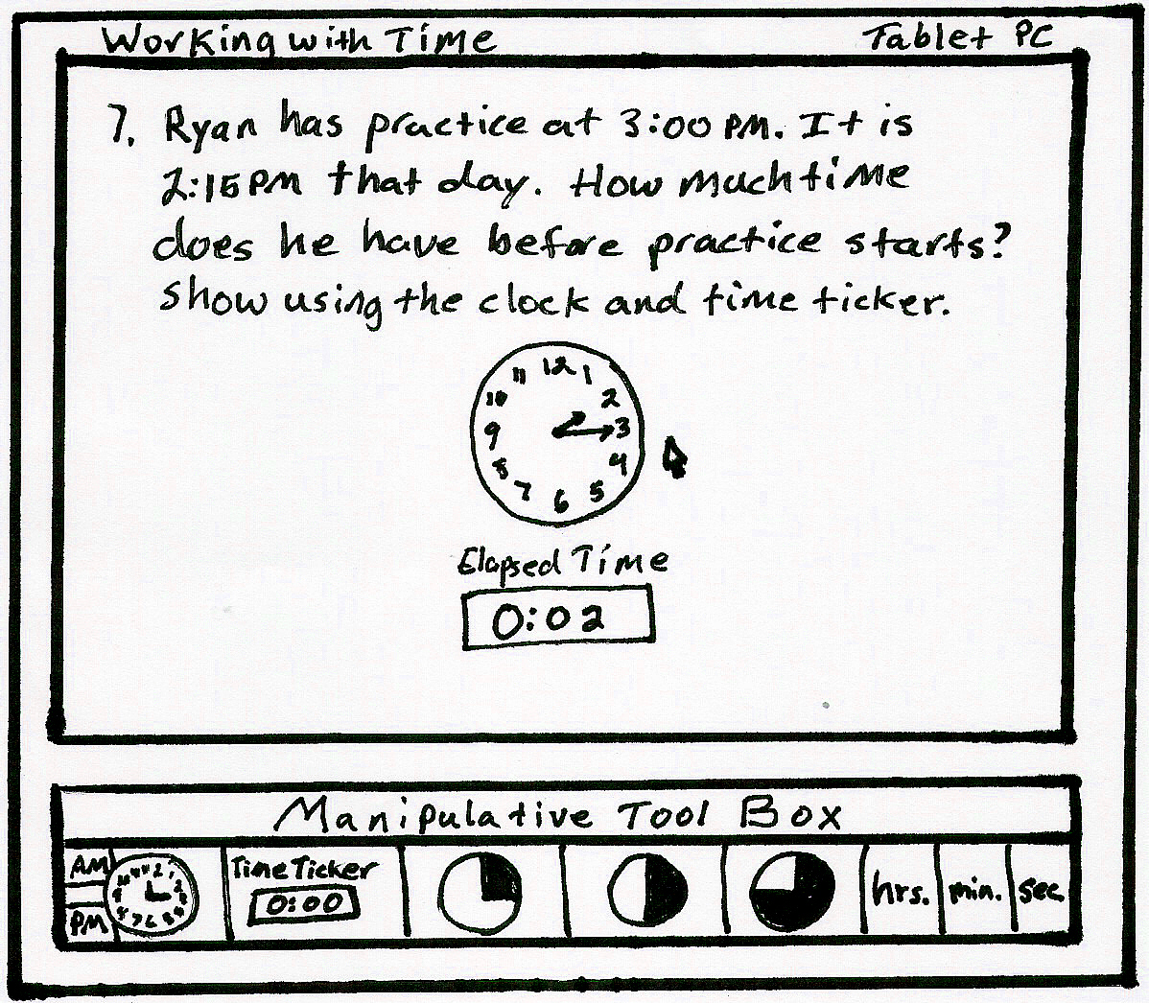
Figure 5:Screen shot of a student working on the Tablet PC with time. Image created by the
author.
Focus Attention:
The focus of attention during the administration of the instruction by the Tablet PCs will be how to solve various styles of word problems asking the students to perform various functions while observing the rules and procedures for positional notation.
Employ Learning Strategies:
An explanation followed by a demonstration will be presented to the students by the teacher using the Smart Board. The explanation of the procedures will help the students refresh their knowledge on this subject and also gain new knowledge while making connections to prior knowledge. The demonstration given as whole-class instruction by the teacher using the Smart Board as an instructional tool will give the students a demonstration of the procedures they will be asked to perform using the Tablet PCs. The demonstration will resemble actions taking place in the screenshots provided above.
Practice:
The students will be provided with time to practice these procedures on their own with the use of Tablet PCs. The software will present the students will different word problems that ask the students to perform various functions dealing with currency, time, and our base-ten numbering system. This pace at which the students practice this material will be student-guided as they are working individually with the tablets.
Learning Strategy:
This learning strategy will be used throughout the entire unit. The strategy being used is one that asks the students to take their knowledge and apply it to various scenarios. By going through the action of applying their acquired knowledge, students will be gaining a full understanding of the material and/or procedures being instructed.
Assessment:
The primary assessments will be provided immediately during the work that students are performing on the tablets. Immediate feedback will be provided and at the end of an instructional set, the total score will be automatically calculated and presented for the student to review. A cumulative assessment will be administered using the Tablet PC after all of the objectives have been instructed to the students. This assessment will be administered using the Tablet PCs and will be automatically scored and graded providing immediate feedback to the students. Other informal assessments will be conducted by the teacher while observing the students working with the material on the Tablet PCs.
Conduct Assessment:
The assessment will be conducted using the Tablet PCs. The students will be provided with immediate feedback as the scores and grades are automatically calculated at the end of each set on the tablets.
Evaluate Feedback-1:
During instruction and individual practice with the Tablet PCs, the teacher will perform several different informal assessments in order to gain a better understanding of how well the students understand the material. The teacher will also provide reinforcing instruction when needed while addressing the individual needs of each student in the classroom.
Evaluate Feedback-2:
While working with the Tablet PCs, the students will be provided with immediate and instructive feedback. If the student answers a question correctly, he or she will receive feedback to inform him of her that the answer was correct and that they are doing a great job. If the answer is incorrect, the student will be provided with a corrective message that informs him or her of what the correct answer was and how they could have approached the problem differently. This feedback will be corrective and instructive while remaining positive in order to encourage the student to keep practicing more with the material.
Evaluate Feedback-3:
At the end of the unit, the students will complete a cumulative assessment administered on the Tablet PCs with problems that are similar to those that they worked with during their individual practice with the material. This feedback will also be immediate in that the program will automatically correct and grade the assessment.
Conclusion:
In conclusion to the lesson the teacher will review and summarize where we have been and where we are going with this instructional concept. We will also talk about how we can transfer our new motivations and understanding to new concepts further in the curriculum. At the end of everything we will have a remotivation period and closure to the unit.
Summary and Review:
At the end of the unit we will summarize where we have been and what knowledge was gained though our instruction, practice, and assessment of the content. We will also review the concepts and procedures that were learned and talk about how we can apply this knowledge to material that we will be covering in the future.
Transfer:
After summarizing and reviewing the concepts and knowledge gained from this instruction we will talk about how we can transfer this knowledge into other content areas. Not only can we transfer the literal knowledge that we gained about solving word problems and following procedures to observe the proper rules of positional notation, but we can also use this same instructional strategy and learning style in other content areas. The process of introducing, demonstrating, practicing, reviewing, assessing, and providing feedback can be used in many different areas in the classroom.
Remotivation and Close:
By going through all of these processes in the conclusion, students will be remotivated about how well everything went with the instruction, attainment of knowledge, and assessment and feedback. They will feel more comfortable about their instruction and feel more positive about their ability to learn through the instructional strategy of learning procedures. This is also a great place to ask for students feedback and comments in order to help students feel understand how much their opinion and thoughts matter in the classroom and the learning process as well.

Instructional management issues
Quality/Performance: The quality of this instructional design will be based on the assessment of the students at the end of this unit. If the assessments show that the students were able to understand and gain knowledge of positional notation, then this instructional design is beneficial to improving math instruction.
Cost: Expenses will include buying the instructional software and any training that is needed for the teachers.
Time: Time will be spent in the district on making sure teachers are adequately trained to use the software in their classrooms. This design will save time in the classroom because the software already includes the manipulatives and assessments so teachers will not have to spend extra preparation time getting them ready.
Scope: This instructional design is for a specific unit in second-grade math that will be built upon the rest of the year.
Lesson Plan One

Lesson Title: Adding and Subtracting Two-Digit Numbers

Course: 2nd Grade Math

Instructor: Math Teacher

Lesson Goal: The goal of the lesson is for students to understand and be able to add and subtract two-digit numbers using positional notation.
Terminal Objective:

Objective 2. Given addition and subtraction problems using two-digit numbers, written both horizontally and vertically, students will be able to demonstrate the correct mathematical procedures to reach the correct result with 86% accuracy.
Desired Learning Outcomes:

- Given different addition problems, students will be able to add two-digit numbers and carry a ten from the one’s place to the ten’s place when necessary.
- Given different subtraction problems, students will be able to subtract two-digit numbers and burrow a ten from the ten’s place and bring it to the one’s place.
Purpose of lesson: The purpose of the lesson is for students to be able to burrow a ten from the ten’s place and carry it over to the one’s place in order to subtract along with taking a ten from the one’s place and carrying it over to the ten’s place when adding.

Equipment needed: Tablet PC for each student, Smart Board, projector, Teacher’s Computer

Materials needed: Math software, whiteboard, notebooks and pencils for each student

Time required: 40-45 minutes for 2 math class periods

Location: 2nd Grade Classroom

Synopsis of Lesson: The lesson will begin by giving students a story problem on the whiteboard that states: “Susan had 14 apples. She gave 9 of them to her friend. How many apples does Susan have left?” Students will try to figure out the answer. Some will figure it out by counting on their fingers. The teacher will write 14-9 vertically and show how to get the answer. Next, the teacher will explain the purpose of the lesson and why adding and subtracting two-digit numbers is so important. The students will previously been introduced to the software that they will be using from the prior day. The teacher introduced the software by modeling it on a Smart Board for the students to see. The body will consist of the teacher explaining how to borrow when adding and subtracting using the whiteboard and one’s and ten’s pieces. Students will learn to start adding or subtracting numbers in the one’s place. They will learn to borrow or carry depending on whether they are using subtraction or addition. Next, the teacher will explain that the students will be using their Tablet PC’s to do practice with addition and subtraction of two-digit numbers. The students will have 15 minutes to go through some practice problems. After so many problems, the students will take a quiz that will assess their understanding. Students will have this class period and the next to get through the first lesson on the Tablet PC. The closing will consist of the students logging off their Tablet PCs and giving their attention to the teacher again. The teacher will review adding and subtracting two digit numbers and will explain the importance of understanding the content. There will be a practice problem on the board or if there were any problems from the lesson on the Tablet PC’s, the teacher could display this on the Smart Board.
Lesson Plan page no. ____

Desired Learning Student Activity Instructor Activity
Outcomes
Introduction: 10 minutes

- Students will become aware 1.Observes teacher open the 1. Teacher opens the
that the lesson on addition and lesson. lesson
subtraction has begun.

- Students become curious 2. Tries to solve story 2. Motivates by
and interested in addition and problem on whiteboard. asking students to
subtraction of two-digit solve story problem.
numbers

3. Students will know what lesson 3. Students listen to 3. Explains what the
covers and what they will be explanation of lesson lesson covers and
doing for the lesson. what will happen
during the lesson.

Body: 20 minutes

4. Students understand 4. Students listen and 4. Uses ones and
procedures for adding and observe examples and the ten’s pieces to model
subtracting two-digit numbers. use of manipulatives borrowing. Puts
examples on
whiteboard

5. Students will practice and 5. Work on Tablet PC on 5. Observing students
be assessed on adding and math software completing work on Tablet PC
subtracting two-digit numbers. lesson 1 and the quiz and answering any
questions

Conclusion: 10 minutes

7. Students will recall experiences 7. Listen and recall 7. Reviews main
points of lesson.

8. Students will realize 8. Listen and imagine 8. Explain how
how to apply the skills they have adding and
learned subtracting are
important in their
lives

9. Knows the lesson is finished 9. Listens 9. Closure: Tells the
students what they are doing the next day and that the lesson is finished

Lesson Plan Two

Lesson Title: Adding and Subtracting Two-Digit Numbers in Story Problems

Course: 2nd Grade Math

Instructor: Math Teacher

Lesson Goal: The goal of the lesson is for students to understand and be able to add and subtract two-digit numbers in story problems using positional notation.
Terminal Objective:

Objective 1. Given various word problems using addition or subtraction, students will be able to reach the exact result, which should be written in correct positional notation, with 72% accuracy.
Desired Learning Outcomes:

- Given a story problem, students will be able to determine if the problem requires addition or subtraction to find the answer.
- Given a story problem, students will be able to pick out the important numbers and use addition or subtraction to find the answers.
Purpose of lesson: The purpose of the lesson is for students to be able to add and subtract two digit numbers in story problems.

Equipment needed: Tablet PC for each student, Smart Board, projector, Teacher’s Computer

Materials needed: Math software, whiteboard, notebooks and pencils for each student

Time required: 40-45 minutes for 2 math class periods

Location: 2nd Grade Classroom

Synopsis of Lesson: The lesson will begin by giving a student seven fake dollars. The teacher will give a scenario where the student wants to buy a new shirt for 16 dollars. The teacher will ask the students to figure out how much more money this student needs to earn before he or she can buy the new shirt. This scenario should interest and motivate the students to want to learn more. The teacher than can introduce the lesson by explaining that the students are going to be using what they know about solving addition and subtraction problems to answer story problem. The teacher will then review adding and subtracting two-digit numbers which is what the students had been learning thus far. The body will consist of the teacher putting words such as altogether, difference, how much more, and total, on the whiteboard. Students will learn that these are clue words that will tell them if a story problem requires addition or subtraction. Students will then learn how to break a problem down and carefully read it to find out what it is asking. Doing this will help them find the important numbers. The teacher will give students a few examples and have them work in small groups to find the answers. Next, students will have 15 minutes to work on lesson two and its quiz on their math software on the Tablet PCs. Students will also have the next math class to finish the lesson or quiz. The closing will consist of the students getting off the Tablet PCs and giving their attention to the teacher. The teacher will review clue words, how to find important information in a story problem, and why solving story problems are important. The students will ask any questions they had. The Smart Board can be used at this time to bring up any questions from the lesson that students did not understand. Finally, the teacher will explain what the students will be doing next class period and end the lesson.
Lesson Plan

Desired Learning Student Activity Instructor Activity
Outcomes
Introduction: 10 minutes

- Students will become aware 1.Observes teacher open the 1. Teacher opens the
that the lesson on addition and lesson. lesson
subtraction in story
problems has begun.

- Students become curious 2. Tries to solve scenario 2. Motivates by
and interested in solving at beginning of class asking students to
story problems. . solve scenario
.

3. Students will know what lesson 3. Students listen to 3. Explains what the
covers and what they will be explanation of lesson lesson covers and
doing for the lesson. what will happen
during the lesson.

Body: 20 minutes

4. Students understand 4. Students listen and 4. Models solving
how to find important numbers observe examples and work story problems and
and key words in story problems. in small groups to solve has students work in
in order to answer them. problems small groups to solve
certain story problems

5. Students will practice and 5. Work on Tablet PC on 5. Observing students
be assessed on solving math software completing work on Tablet PC
story problems by adding lesson 2 and the quiz and answering any
and subtracting two-digit questions
numbers

Conclusion: 10 minutes

7. Students will recall experiences 7. Listen and recall 7. Reviews main
points of lesson.

8. Students will realize 8. Listen and imagine 8. Explain how
how to apply the skills they have adding and
learned subtracting are
important in solving story problems

9. Knows the lesson is finished 9. Listens 9. Closure: Tells the
students what they are doing the next day and that the lesson is finished

Formative, summative and return on investment evaluations
This instructional design will include a number of assessments in order to measure students understanding of this unit. Formative assessments will include teacher-led lessons using manipulatives, group activities, questioning, and Tablet PC lessons and quizzes. A summative assessment will include a cumulative assessment at the end of the unit on positional notation. There will not be a formal assessment on the students’ attitudes on the instruction for positional notation. There will be a review period at the end of the unit where the students will be able to discuss what they thought about the unit.

Appendix A: Complete Test Form
Positional Notation Test
Directions: Answer the following addition and subtraction problems following the rules of positional notation. Show all work.
- 13 + 7 = ________

- 11 + 19 = ________

- 16 – 9 = _________

- 20 -11 =_________

- 14 -8 =__________

- 17
+7

- 16
- 7

Part 2
Directions: Carefully read the word problem and select the important information to construct your addition or subtraction problem. Please label your answers.
- Janet made 12 cookies in the morning. Arthur came over in the afternoon and ate five cookies. At the end of the day, how many cookies are left in the cookie jar?

- Tom had 11 baseball cards. His dad bought him a pack that contained 9 cards. How many cards does Tom have altogether?

- Ray has 10 goldfish. Mary has 14 goldfish. How many more goldfish does Mary have then Ryan?

- Bill has a bag of 16 apples. Todd and Kayla had 7 more apples to his bag. How many apples are now in Bill’s bag?

- Anna invited 18 friends to her party. Only 9 friends showed up. How many of Anna’s friends did not come to her party?

- Joe has 8 pairs of shoes and Lana has 13 pairs of shoes. How many shoes do Joe and Lana have together?

- Nate’s dad drives 15 miles to work. Larry’s dad drives 8 miles to work. How many more miles does Nate’s dad drive then Larry’s dad?

Part 3
Directions: Solve the addition or subtraction problem by observing the rules of positional notation. Make sure you notice what variable you are working with. Label your answer accordingly.
- Jan went to the store with $20 in her pocket. She bought a shirt for $12.50. How much money is left in Jan’s pocket after her purchase?

- $8
- $7
- $7.50
- $32.50

- Ryan has practice at 3:00 PM. It is 2:15 PM that day. How much time does he have before practice starts?

- 45 minutes
- 1 hour and 45 minutes
- 30 minutes
- 1 hour and 15 minutes

- Corey had $17 saved. He washed Mrs. Smith’s car for $9.75. How much money does Corey have altogether?

- $27
- $26.75
- $8.75
- $26

- Kim decided to go for a job at 5:45PM. She ran for 17 minutes. What time was it when she got back from her job?

- 5:00 AM
- 5:62 PM
- 5:38 PM
- 6:02 PM

- Jared needs to be to school at 8:05 AM. It is 7:30 AM and he is just getting on his bike. How many minutes does Jared have to get to school?

- 1 hour and 30 minutes
- 30 minutes
- 35 minutes
- 25 minutes

- Kelly got $15 from her grandpa for her birthday. Her friend gave her $7. How much money did Kelly get for her birthday?

- $22
- $8
- $14
- $20

- Tom really wants a baseball cap that costs $20. He only has $11.50. How much more money does he need to buy the baseball cap?

- $9
- $8.50
- $31.50
- $8

References
(2008). South Dakota Content Standards. Retrieved July 1, 2008
from South Dakota Department of Education Web site:
http://doe.sd.gov/contentstandards

Smith, P.L., & Ragan, T.J. (2005). Instructional Design (3rd
ed.). The University of Oklahoma: John Wiley & Sons, Inc.

Tables
Table 1
Instrument Blueprint
Terminal Objectives | Form | Number of Items | Criterion Level | Proportion
Objective 1 | CR | 7 | 5/7 | .333
Objective 2 | CR | 7 | 6/7 | .333
Objective 3 | MC | 7 | 5/7 | .333

Figures
[Insert Figure Legends here]
Is this a subtraction problem?
Yes
No
Select Another Approach
Recall the steps in subtracting 2 digit numbers
Is this a word story problem?
No
Yest
Begin regular subtraction procedure.
Select appropriate information and write into vertical equation
Subtract numbers on right column (ones place)
If bottom number is larger than the top number, you need to borrow from tens column. One ten equals ten ones. Write difference below
Subtract the 2 numbers from the tens column and write below the difference.
Make sure the numbers in the difference are written in the proper positional notation
If answer does not make sense go through procedures again to find mistake
Figure 1
Is this an addition problem?
Yes
No
Select Another Approach
Recall the steps in adding 2 digit numbers
Is this a word story problem?
No
Yest
Begin regular addition procedure
Select appropriate information and write into vertical equation
Add 2 numbers on right column (ones place)
If sum of these 2 numbers is larger than 9, carry the tens over into the tens column (left column)
Add 2 digits plus any number that was carried over from ones column in the tens column.
Make sure the numbers in the sum are written in the proper positional notation
If answer does not make sense go through procedures again to find mistake
Figure 2
Selecting appropriate information in a word story problem
Recognizing key words
Left or Left over
How many more
Difference
Total
Sum
All Together
Represents Subtraction
Represents Addition
Select the correct numbers and use these representations to correctly set up the equation.
Figure 3
Figure 4: Screen shot of a student working with currency. Created by author.
Figure 5: Screen shot of a student working with time. Created by author.

